PRACTICE PAPER 2
Speaking Practice Task
Preparation: 30 seconds Recording: 60 seconds

Talk about one of your best friends.

Speaking Task 1: Giving Advice
Preparation: 30 seconds
Recording: 90 seconds
A classmate is not doing well in math class and has received several low grades. If this continues, he will not be able to pass the final exam. Give your classmate advice on what he should or should not do if he would like to improve his grades.
Speaking Task 2: Talking about a Personal Experience
Preparation: 30 seconds
Recording: 60 seconds
Talk about a time when something did not happen the way you first expected. Maybe you can talk about something that did not happen according to plan when you were working on a project, or when you were trying to accomplish something. At first, how did you expect things to happen, how did they actually happen, and what was your response?
Speaking Task 3: Describing a Scene
Preparation: 30 seconds
Recording: 60 seconds
Describe some things that are happening in the picture below as well as you can. The person with whom you are speaking cannot see the picture.

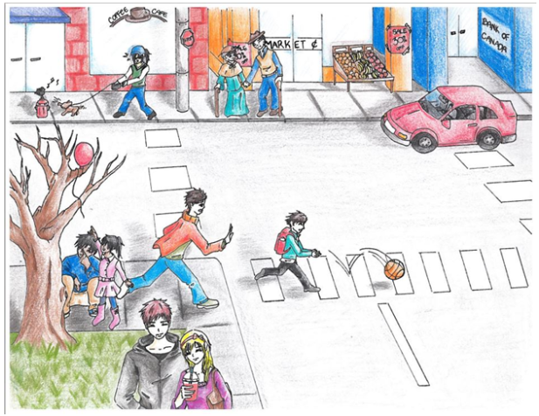

Speaking Task 4: Making Predictions
Preparation: 30 seconds
Recording: 60 seconds
In this picture, what do you think will most probably happen next?

Speaking Task 5: Comparing and Persuading
Instructions
This task is made up of THREE parts:
- Choose an option
- Preparation time
- Speaking
Your company is planning to move to a new office soon, and your boss has asked you to help find a new location. You find two suitable options. Using the pictures and information below, choose the option that you prefer. In the next section, you will need to persuade your boss that your choice is the better choice.
If you do not choose an option, the computer will choose one for you. You do not need to speak for this part.
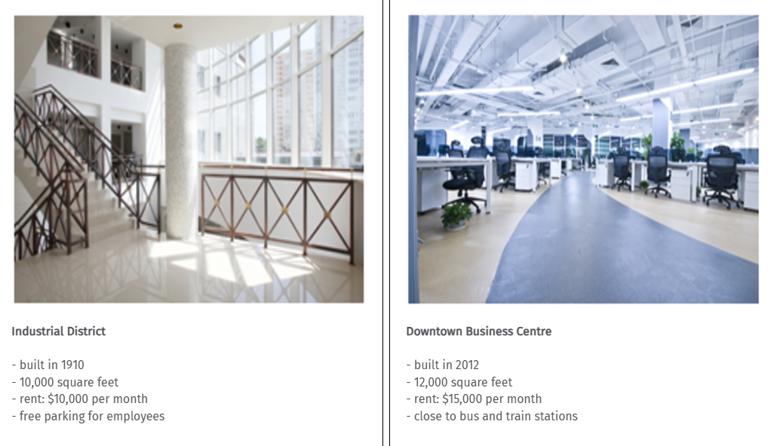

Your boss is suggesting another office. Persuade her that the office you chose is more suitable by comparing the two.
(NOTE: In the examination, one of the two following windows appears, and you get 60 seconds to prepare before recording the answer)
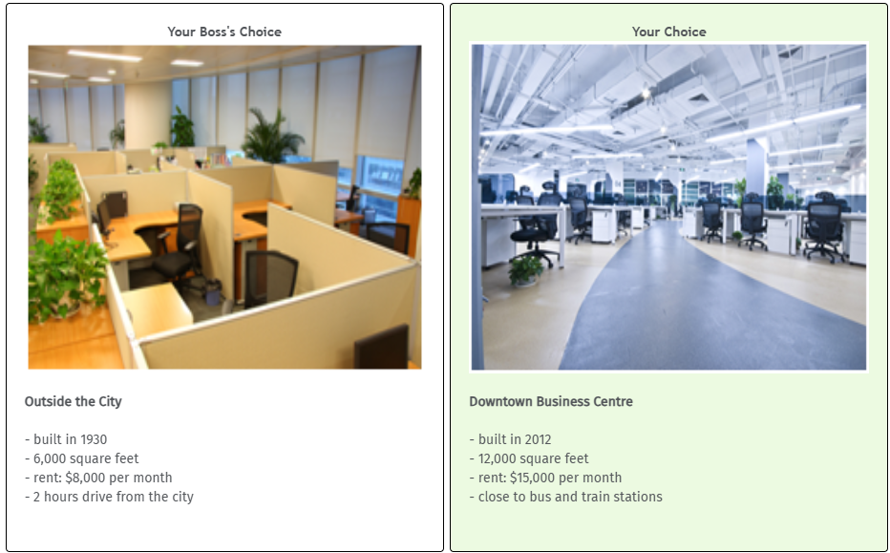

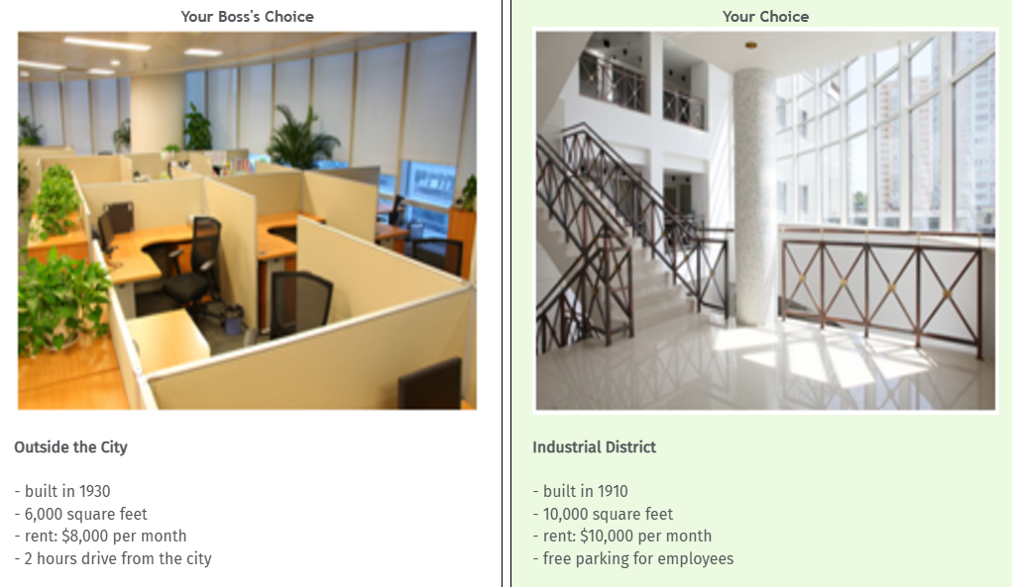

Speaking Task 6: Dealing with a Difficult Situation
Preparation: 60 seconds
Recording: 60 seconds
Your child’s school has asked you to help with a class field trip. Your friend bought you tickets to a baseball game for that same day. The school will cancel the field trip if there are not enough parents, but your friend will be upset if you cannot go to the baseball game because the tickets were expensive.
Choose ONE:
EITHER
Talk to the school. Explain why you cannot help with the field trip.
OR
Talk to your friend. Explain why you cannot attend the game.

Speaking Task 7: Expressing Opinions

Preparation: 30 seconds
Recording: 90 seconds

Answer the following question.
Question: Do you think all university students should study abroad for a year, if there is sufficient funding? Explain your reasons.

Speaking Task 8: Describing an Unusual Situation
Preparation: 30 seconds
Recording: 60 seconds
You see a group of people playing a sport at a recreation centre. Call your friend Betty and describe in detail what the sport is like and what each player is doing. Ask her if she would be interested in trying this sport sometime.

