**PRACTICE PAPER-1**

**Speaking Practice Task**

Preparation: 30 seconds

Recording: 60 seconds

**Talk about one of your best friends.**

**Speaking Task 1: Giving Advice**

Preparation: 30 seconds

Recording: 90 seconds

**A friend is looking for a summer job. Advise him about different ways he can find work for the summer.**

**Speaking Task 2: Talking about a Personal Experience**

Preparation: 30 seconds

Recording: 60 seconds

**Talk about a great time you had with a family member or friend. Maybe you can talk about a party, something you did together at school, a time you travelled with a friend, or anything else you can remember. What happened and why was it memorable?**

**Speaking Task 3: Describing a Scene**

Preparation: 30 seconds

Recording: 60 seconds

**Describe some things that are happening in the picture below as well as you can. The person with whom you are speaking cannot see the picture.**

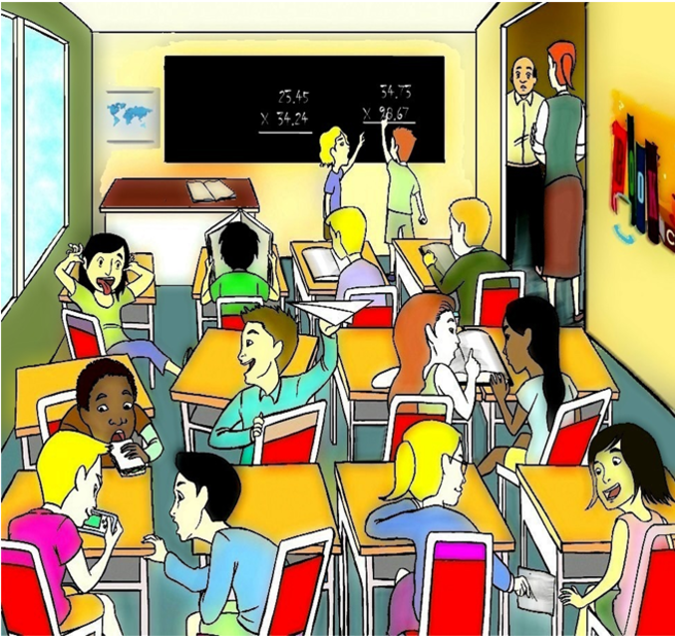

**Speaking Task 4: Making Predictions**

Preparation: 30 seconds

Recording: 60 seconds

**In this picture, what do you think will most probably happen next?**

**Speaking Task 5: Comparing and Persuading**

**Instructions:**

**This task is made up of THREE parts:**

1. **Choose an option**
2. **Preparation time**
3. **Speaking**

**Your family is relocating to another area, and you are looking for a new home there. You found two suitable options. Using the pictures and information below, choose the option that you prefer. In the next section, you will need to persuade a family member that your choice is the better choice.**

**If you do not choose an option, the computer will choose one for you. You do not need to speak for this part.**

**Your family is suggesting another house. Persuade your family member that what you chose is more suitable by comparing the two.**

**(NOTE: In the examination, one of the two following windows appears, and you get 60 seconds to prepare before recording the answer)**

**Speaking Task 6: Dealing with a Difficult Situation**

Preparation: 60 seconds

Recording: 60 seconds

**A close cousin who lives in another country is coming to visit for a year. She tells you that she would like to stay at your place to explore your country’s culture and to spend some time with you. Your roommate does not agree, and says you will have to move out if she comes.**

**Choose ONE:  
EITHER  
Talk to your cousin. Explain why she cannot move in for a year.  
OR  
Talk to your roommate. Explain why your cousin should be allowed to move in with you for a year.**

**Speaking Task 7: Expressing Opinions**

Preparation: 30 seconds

Recording: 90 seconds

**Answer the following question.  
  
Question: Do you think that young adults should pay rent to their parents if they do not move out by the age of 21? Explain your reasons.**

**Speaking Task 8: Describing an Unusual Situation**

Preparation: 30 seconds

Recording: 60 seconds

**You are in a furniture store, and you see a table you would like to buy, but the store clerk won’t let you take a photo. Phone a member of your family. Provide a full and clear description of the table and ask if you can buy the table.**

